Quadratic Links 3
Matching
The following ‘cards’ are in no particular order
Use the cards, either by cutting them out or by labeling, to create 6 groups. Each graph card has 4 corresponding text cards that go with it!

In this case, however, all but one of the text cards are blank as well as the graph cards!

Your task now is to deduce from the text card you have, what should be written on the others and then make a mathematical ‘sketch’ of the graph on one of the blank cards!

As before, an example of what a finished group might look like is shown below

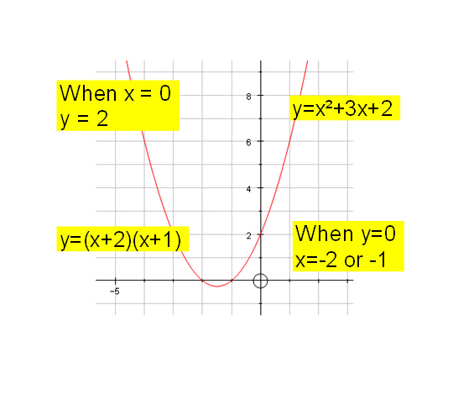

y= x² + 9x + 18 | y = | When x = 0,  y = | When y = 0,  x =
y= x² - 9 | y = | When x = 0,  y = | When y = 0,  x =
y= x² - 3x + 2 | y = | When x = 0,  y = | When y = 0,  x =
y=x² + 7x + 6 | y = | When x = 0,  y = | When y = 0,  x =
y= x² + 8x + 12 | y = | When x = 0,  y = | When y = 0,  x =
y= -x² +6x - 9 | y = | When x = 0,  y = | When y = 0,  x =

